27th February 2015

**YOKOHAMA Marine Hoses Receive API Spec Q1 Certification**

Tokyo ‒ The Yokohama Rubber Co., Ltd., announced today that its marine hoses employed for offshore crude oil transfer have been certified by the American Petroleum Institute as conforming with API Specification Q1 9th Edition (API Spec Q1). API Spec Q1 specifies the quality management system requirements for manufacturing organizations involved in the oil and gas industries, and helps for certified company to enhance the social reputation through its strict standards for risk assessment and revision control in the manufacturing process.

The API Spec Q1 has been recognized in the oil and gas industries for many years as one of the most authoritative certification in the industries. In response to demands from some marine hose users for the world’s highest level of quality standard, YOKOHAMA has acquired the certification of the API Q1.

YOKOHAMA marine hoses known as Seaflex brand has enjoyed the excellent reputation in the market, and has played a major role in offshore crude oil transfer for more than 55 years. With the increase in quality awareness, YOKOHAMA will continue to contribute to the safest crude oil transfer operation as the world’s leading manufacturer of marine hose.

With an eye on the growing global demand for marine hoses in recent years, YOKOHAMA has been aggressively expanding its overseas production network. In September 2014, the Company acquired an Italian marine hose manufacturer. In addition, it is currently constructing a plant for the manufacture of marine hoses and pneumatic fenders on the island of Batam in Indonesia, with production scheduled to begin in the latter half of 2015.

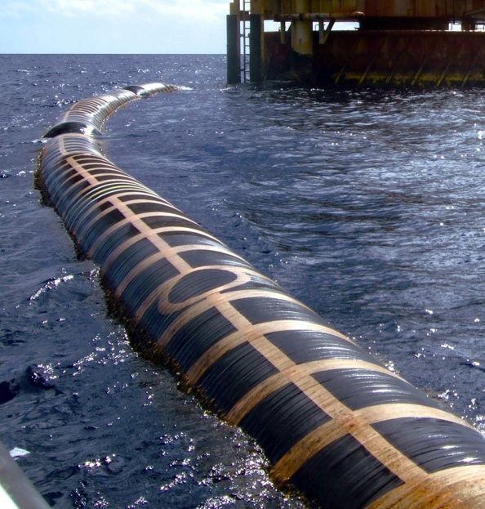

*A YOKOHAMA Seaflex hose in action*

*during a crude oil transfer operation*

*YOKOHAMA´s API Spec Q1 certification*